IN AZERBAIJAN INTERNATIONAL TRANSPORTATION SYSTEM:
GOALS AND PERSPECTIVES INTERNATIONAL SCIENTIFIC-PRACTICAL CONFERENCE

The program of the conference

The main goal of the international scientific-practical conference "Azerbaijan in the International Transport System: Goals and Perspectives" to be held on May 24-25, 2024, is to develop research skills in higher education institutions and to make significant contributions to science by discussing the current problems of transport, including transport logistics, Conducting scientific discussions and advancing proposals for solutions related to the operation of transport corridors, traffic management, safety and risk management in transport, reliability of vehicles, global warming of great importance for the world and the region, reduction of carbon dioxide emissions in the transport sector and transition to alternative energy is to ensure driving. To contribute to the future of our country in this direction, we invite scientists and engineers working in different countries around the world, professors and teachers of universities, doctoral students, dissertation candidates, and masters to the international scientific conference to share and discuss the results of their scientific and practical work.

Articles selected by the Organizing Committee and presented to the conference will be published in the collection of conference materials.

The work of the conference will be organized in the following sections:
- Logistics organization of the transport system in Azerbaijan
- Transport technologies and innovations
- Investment and business planning in transport
- Transport corridors and supply chain management issues
- Environmental problems in transport and sustainable transport

Conference schedule:
April 30, 2024, is the deadline for submission of electronic versions of materials.
Until May 15, 2024: Submitted papers undergo peer review. The Program Committee will inform the authors about the acceptance/rejection of articles.

Working languages of the conference:
The work of the conference will be conducted in Azerbaijani, English, Russian, and Turkish languages in plenary and sectional sessions.

General Information
A template has been provided to prepare an article to be presented at the conference. The article can be designed directly on the template. Articles that do not conform to the template and are prepared in different formats will not be accepted or printed. The author is directly responsible for this. Articles will be sent via e-mail to logistics@beu.edu.az. In the subject of the e-mail, it must be mentioned to which field the article is sent (logistics organization of the transport system in Azerbaijan, transport technologies and innovations, investment and business planning in transport, problems of transport corridors and supply chain management, information technologies in transport, environmental problems of transport and sustainable transport). Articles must be sent by April 30, 2024. Articles sent after the mentioned date will not be considered. Only original research papers (not published or presented elsewhere) should be sent to the conference. The scientific committee of the conference will evaluate the presented articles. Regardless of the language in which the article is sent (Azerbaijani, Turkish, English, or Russian), it must follow the language rules and at a fully understandable level. Articles that do not comply with the writing rules and conference requirements will not be accepted.
Conference materials will be published online.
You can contact the Organizing Committee for more information.
Contact addresses:
AZ 0101, Khirdalan city, Hasan Aliyev street, 120, Baku Engineering University
Email: logistics@beu.edu.az
Contact number: 055-745-09-46

ARTICLE TITLE,
AUTHOR'S NAME, SURNAME
Name of the University/Institute
Faculty/Department Name
e-mail
CITY, COUNTRY
1. Summary:
A brief overview of the research study. The relevance, purpose, scientific novelty, practical importance, advantages, and results of the work should be included here. The abstract should be one paragraph and 200-250 words. Abbreviations, references, and quotation marks should not be used.
If the article is not written in English, then the abstract should also be given in English.
2. Keywords: keyword-1, keyword-2, keyword-3
Keywords should be listed after the abstract.
3. Introduction
In the introduction, the goals and objectives of the research work, relevance, scientific innovation, practical importance, method and methodology, placement in the scientific literature, etc. are displayed. In general, the introduction should consist of the following 4 parts:
1. Brief information related to the research work is provided. The relevance and importance of the work is indicated.
2. The need for research work is indicated. Currently, completed jobs and issues are displayed.
3. The research work to achieve the set goal is disclosed.
4. The structure of the research work is shown.
4. Research method
Methods and materials used to solve the problem are shown. Tables, block diagrams, and graphs obtained as a result of conducted scientific experiments are shown. In this chapter, the efficiency of the research work is not disclosed, but the experiments and their results are disclosed.
5. The result
The results of the conducted research are discussed. Accomplishments, advantages, and work efficiency are noted.
6. Reference list
References in the research paper are cited according to APA style. That is, at the end of the reference sentence, the last name of the author (or authors) and the date of publication are indicated in parentheses. For example: (Gasimov, 2023). A period is placed after the reference. References should follow the following pattern:
1. Janic, M. (2007). Modeling the full costs of an intermodal and road freight transport network. Transportation Research Part D: Transport and Environment. 12 (1): 33–4
2. Flyvbjerg, B., Skamris Holm, MK, Buhl, SL (2006). Inaccuracy in traffic forecasts. Transport Reviews. 26 (1): 1–24.
3. Behdani, B., Fan, Y., Wiegmans, B., Zuidwijk, R. (2016). Multimodal schedule design for synchromodal freight transport systems, European Journal of Transport and Infrastructure Research. 16 (3): 424–444
4. Woodburn, A. (2012). Intermodal rail freight activity in Britain: Where has the growth come from? Research in Transportation Business and Management. 5: 16–26

Additional
Format of Сhapters and Texts
Formatting (font name, size, margin spacing, etc.) corresponding to each section (main heading, subheading, text, list, etc.) is given in the template to compose the article. When working on the report template, the required format will be preserved. Changing this format is not allowed.
The text of the article should be between 1200 and 3500 words.

Figures and tables
The picture, graph, block diagram, table, etc. are given in the research work. should match the pattern below. Figures (graphs, flowcharts, and tables) should be placed in the middle of the text.
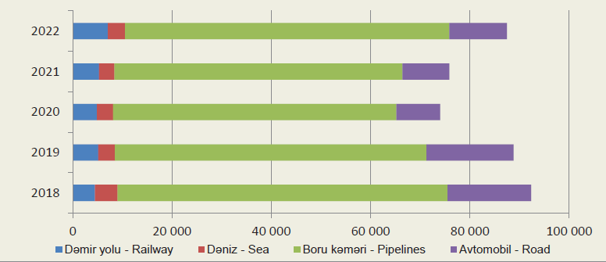

Figure 1. Freight turnover in the transport sector of Azerbaijan, million ton-kilometers, 6 pt space should be left between the image, the description of the image, and the text. Each image should have a number and an explanation of the image in the text. When an image is taken from another source, a reference must be given.

Table 1 . Freight transportation in the transport sector in the Republic of Azerbaijan, in % compared to the previous year

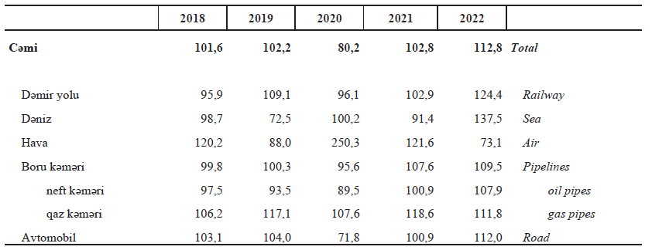

Source: " State Statistical Committee of the Republic of Azerbaijan, 2023", " State Statistical Committee of the Republic of Azerbaijan, 2023 "

Equations
Each equation given in the text should be numbered. Equations should be written in the middle.
$α+β=γ$ (1)
Important note:
1. Having articles in a single column,
2. The pages in the article should not be divided by "page breaks",
3. Group the shapes used for any shape used within the article.

Contact information:
Contact: The responsible secretary of the conference - Assoc. Nijat Karimov
Phone: +994 (12) 349 99 66/67

Fax: +994 (12) 349 99 90
Mobile & WhatsApp: (+994 55) 745-09-46
Email: logistics@beu.edu.az
Address: Baku Engineering University, Khirdalan city, Hasan Aliyev street, 120

